Experiment No. 4

Aim: To implement and demonstrate Inter Process Communication in client server environment using Java.
Theory:
“Inter-process communication is used for exchanging useful information between numerous threads in one or more processes (or programs).”
Inter-process communication (IPC) is a mechanism that enables different processes or threads to exchange data and communicate with each other in a computer system. IPC is essential in modern operating systems and distributed systems where multiple processes are running concurrently and need to coordinate their activities.
There are several ways in which IPC can be achieved:
Shared memory: This method involves sharing a common area of memory between processes, which can be accessed and modified by multiple processes. This enables processes to share data and communicate with each other through the shared memory.
Message passing: This method involves sending messages between processes. The sender process puts a message into a message queue, and the receiver process retrieves the message from the queue. This enables processes to communicate and exchange data with each other.
Pipes: This method involves creating a unidirectional communication channel between processes. One process writes data to the pipe, and the other process reads data from the pipe. This enables processes to transfer data and communicate with each other.
Sockets: This method involves using network sockets for communication between processes running on different machines, or even on the same machine. This enables processes to communicate and exchange data over a network.
Remote Procedure Calls (RPCs): This method allows a process to call a procedure on another process running on the same machine or a remote machine. This enables processes to communicate and exchange data by calling procedures on each other.
These IPC mechanisms provide different ways for processes to communicate and exchange data, depending on the specific requirements of the application and the underlying operating system.
Client-server architecture is a model in which multiple clients request and receive services from a centralized server. The server hosts the resources or services, and the clients connect to the server to use those services. This architecture is foundational in network computing and is widely used in web applications, database servers, and network communication systems.
Sockets are an abstraction used to facilitate communication between two entities over a network. A socket is one endpoint of a two-way communication link between two programs running on the network. The most common use of sockets is to enable communication between a client and a server.
In this experiment, we are using Java's networking capabilities to establish a simple connection between a client and a server using TCP (Transmission Control Protocol). TCP is a reliable, connection-oriented protocol that ensures data is delivered in the same order in which it was sent.
Steps in the Experiment:
1. Server Side:
- The server creates a `ServerSocket` on a specific port (e.g., `6666`).
- The server waits for a client to connect using the `accept()` method.
- Once a connection is established, the server uses a `DataInputStream` to receive two integers from the client.
- The server adds these integers and prints the result on the console.
- The server then closes the connection.
2. Client Side:
- The client creates a `Socket` object and connects to the server at the specified port.
- The client prompts the user to input two integers.
- These integers are sent to the server using a `DataOutputStream`.
- The client then closes the connection.
This experiment demonstrates the basic principles of network programming, specifically inter-process communication (IPC) through sockets. It provides a fundamental understanding of how clients and servers communicate over a network, which is essential for developing distributed systems and networked applications.
Conclusion:
The experiment successfully implemented a simple client-server communication system using Java sockets. The server was able to receive two integers from the client, compute their sum, and output the result. This experiment highlights the ease of setting up basic network communication in Java and provides a foundation for more complex networking tasks. Understanding client-server architecture and socket programming is crucial for developing applications that require network-based interactions, such as web servers, chat applications, and online multiplayer games.

Name: Prachi Gujar
Roll no: 1 Batch: S1
Experiment no: 4
//Server Program
import java.io.*;
import java.net.*;
public class server{
public static void main(String[] args)
{
try{
ServerSocket ss=new ServerSocket(6666);
Socket s=ss.accept();//establishes connection
DataInputStream dis=new DataInputStream(s.getInputStream());
int a=(Integer)dis.readInt();
int b=(Integer)dis.readInt();
System.out.println(a+b);
ss.close();
}
catch(Exception e){
System.out.println(e);
}
}
}

// Client Program
import java.io.*;
import java.net.*;
import java.util.*;
public class client {
public static void main (String[] args){
Scanner userInput = new Scanner(System.in);
try{
Socket s= new Socket("localhost",6666);
DataOutputStreamdout=new DataOutputStream(s.getOutputStream());
System.out.println("Enter 1st no:");
int a= userInput.nextInt();
System.out.println("Enter 2nd no:");
int b= userInput.nextInt();
dout.writeInt(a);
dout.writeInt(b);
dout.flush();
dout.close();
s.close();
}
catch(Exception e){
System.out.println(e);
}
}
}

Output:-
//Server Program Output
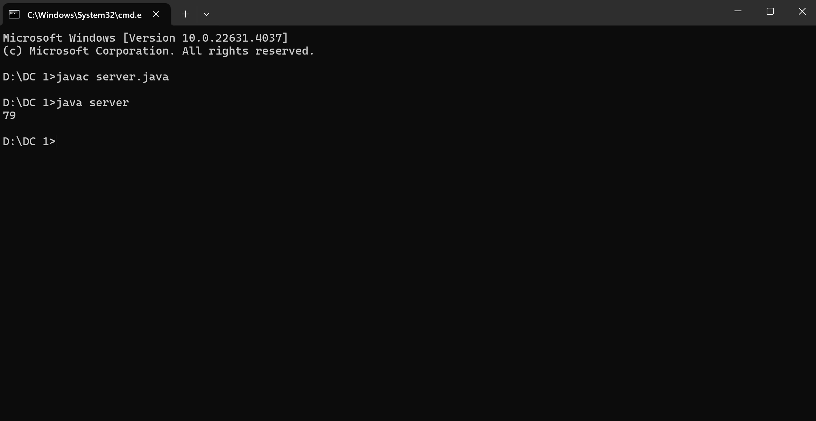
//Client Program Output
